Board infinity minor project
Application code

<!DOCTYPE html>
<html lang="en">
<head>
<meta charset="UTF-8" />
<meta name="viewport" content="width=device-width, initial-scale=1.0"/>
<title>Queue Reversal</title>
<script defer>
function reverse() {
const val = document.getElementById('inp').value;
const nums = val.split(',').map(x => parseInt(x.trim())).filter(x => !isNaN(x));

let stk = [];
let rev = [];

for (let n of nums) stk.push(n);
while (stk.length) rev.push(stk.pop());

document.getElementById('out').textContent = "Reversed: " + rev.join(', ');
}
</script>
<script src="https://cdn.tailwindcss.com"></script>
</head>
<body class="min-h-screen bg-gray-100 flex items-center justify-center">
<div class="bg-white p-6 rounded-2xl shadow-md w-full max-w-md">
<h1 class="text-xl font-bold text-center text-gray-800 mb-4">Queue Reversal</h1>

<label for="inp" class="block text-sm text-gray-600 mb-2">Enter numbers (comma separated):</label>
<input
id="inp"
type="text"
class="w-full p-2 border border-gray-300 rounded-lg focus:ring-2 focus:ring-blue-500 outline-none"
placeholder="e.g., 1, 2, 3, 4"
/>

<button
onclick="reverse()"
class="mt-4 w-full bg-blue-600 hover:bg-blue-700 text-white font-semibold py-2 rounded-lg transition"
>
Reverse
</button>

<p id="out" class="mt-5 text-center text-green-700 font-medium text-lg"></p>
</div>
</body>
</html>

Screenshots of the application:
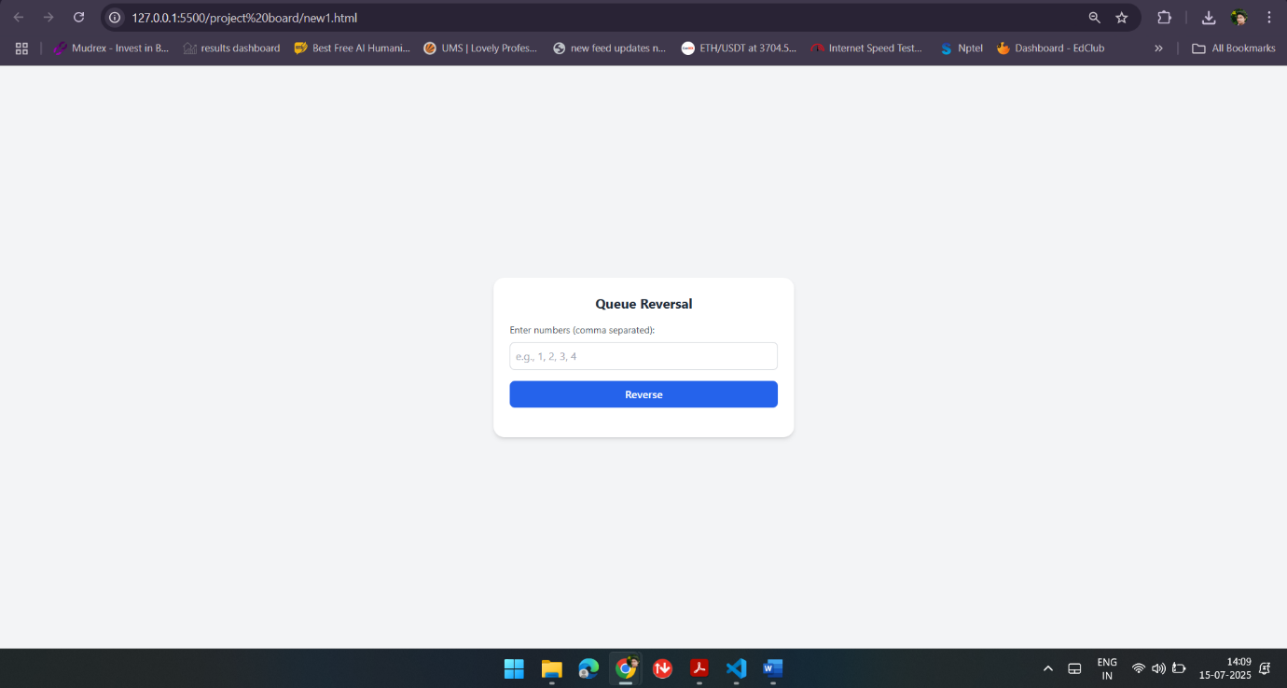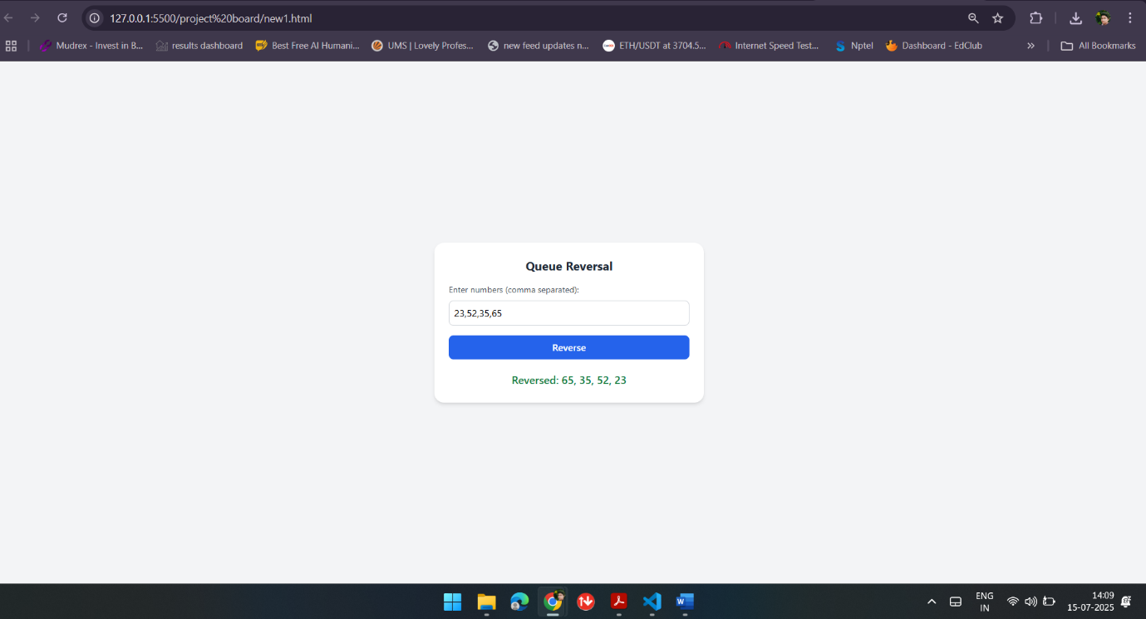

Github repository link:
https://github.com/Charan57290/Queue-revesal-tool.git

